Eric Zorn

10/15/2017

ICT 4300

Professor/Dr. Lakhani

**Module 6 Homework – ICT 4300 MySQL**

**\*\*\*\*ALL QUESTIONS ARE ON SEPARATE PAGES. MySQL LAB QUESTIONS ARE ON THE LAST PAGE!**

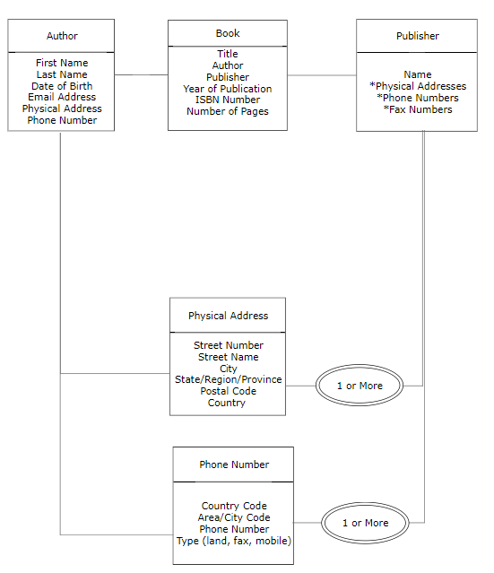Question 1:

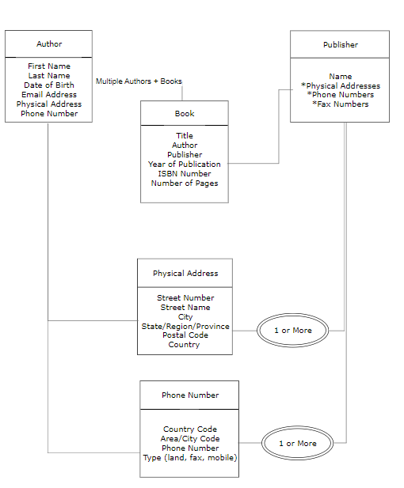Question 2:

Question 3:

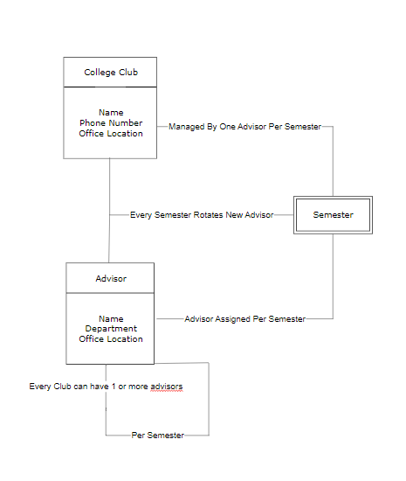

MySQL Lab #2 Questions:

1. How many databases are included in your system? List all the databases in your system.
   1. In the MySQL workbench software, I currently have five different databases. One of them is the Student database that we had added last week during Module 5 and then modified by adding data this week in Module 6. Here are the databases:
      1. Information Schema
      2. MySQL
      3. Performance Schema
      4. Student
      5. SYS
2. How many tables were created by the demobld.sql script?
   1. There were six tables that were created from the script that we imported in total that all were within the student database. These are the tables:
      1. Cost table
      2. Customers
      3. Invoices
      4. Organizations
      5. Shipment items
      6. Shipments
3. Describe all the tables created by the demobld.sql script
   1. Cost Table has 6 fields in the cost table that are comprised of shipper, min_size, max_size, max_weight, time_frame, and cost_factor. Shipper has a type of varchar (40). Min_size through max_weight have the type of double (6.2). Time_frame has a type of double (3.0) and cost_factor has a type of double (4.2). None of the fields are null, nor do they have keys or extra. Their default is Null.
   2. Customer has 11 fields, customer ID, credit rating, last name, first name, title, organization ID, street, city, state, zip, and comments. Items that would include numbered values like customer id, organization id, and zip all have types of double. The rest of the types are varchar for items like names, address, titles, and credit ratings as well. The only fields that are not considered null are the customer ID and the last name. The only field that has a key is the customer ID and it is a key of PRI. All of the fields have a default of null and no extra.
   3. The Invoice table has three fields, invoice ID, customer ID, and Invoice Date. Both of the customer IDs and the invoice IDs have a type of double, while the invoice date has a type of date. Invoice and customer ID also are not Null, while Invoice Date is. Invoice ID has a key of PRI and is the only field with a key. All fields have a default of null and no extra.
   4. The organizations table has three fields as well, Organization ID, name, and tax code. The organization field has a type of double, while name and tax code have a type of varchar. Tax code also is the only field that is Null. Organization ID has a key of PRI and defaults of null. There also is not an extra.
   5. The shipment items table has eight fields, item ID, shipment ID, quantity, description, height, width, weight, and ship cost. All of the fields are types of double except for the description field, which is a type of varchar. Item ID, Shipment ID, and quantity are the only fields that are not Null. Item ID has a key of PRI. All fields are default null and do not have any extras.
   6. The shipments table has 17 fields. These are shipment ID, Invoice ID, from name, from street, from city, from state, from zip, to name, to street, to city, to state, to zip, est ship date, shipper, ship cost, tracking number, and comments. The types of shipment ID, Invoice ID, from zip, to zip, and ship cost are all doubles. Est ship date is type of date and the rest are all varchar. Shipment ID is not null and has a key of PRI while all of the other fields are Null and do not have keys. Shipment ID also has a default of 0, while the rest of the fields are default of null. None of the fields have an extra.